CASINO ADMIN (Open only in IE browser)
- Search for player in FIND section
- Go to the BONUS tab
- You’ll see that there are 4 tabs for the different types of bonus: Cash, Bonus Play, Pending Bonus Money and Bonus Money.
BONUS PLAY
It works like a separate wallet. When a Bonus Play is added, it creates a tab on the casino lobby called Bonus Play. When you click on the tab it shows the amount and required rollover, a player can select a game from the drop down menu and play just that bonus money. When the rollover is met, he will see the bonus money go to zero and his real money account go up however much bonus money he had. In this option it’s like the bonus money is held in a separate account that can only be used by casino.
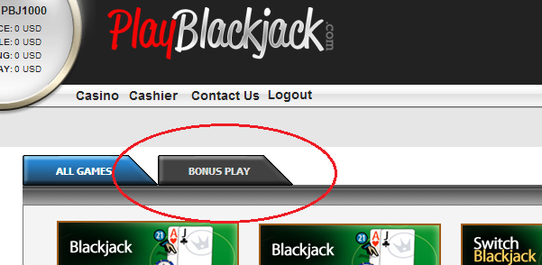

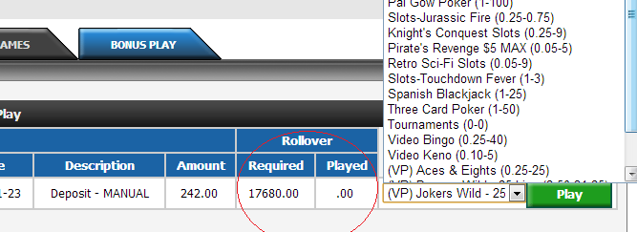
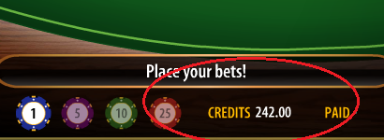
Pending Bonus Money
In this case the bonus money is played last so it only gets used after he plays his real money.
You can give a player $50 bonus in SLOTS and he will see his balance increased $50 only when he is in a slot machine. This is good for things like bingo, slots and keno where you can give 200% bonuses because the money is played after the real money and those games have solid hold percentages. This can also be qualified or unqualified. Unqualified bonus money has a rollover associated with it to get the bonus money.
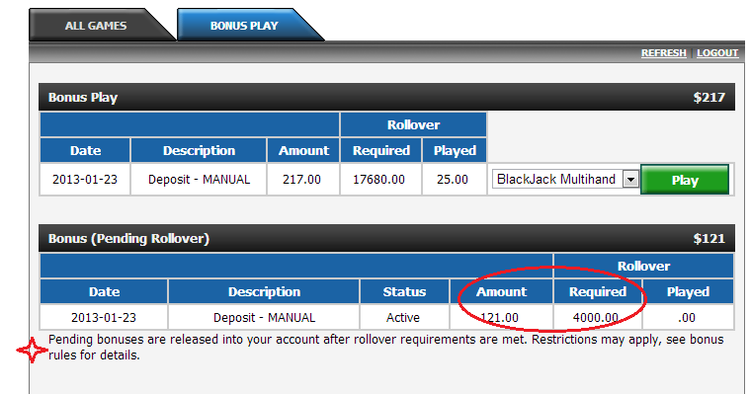
Bonus Money
This option is mainly used by CASINO ONLY sites. The money is added right away to the players account and the casino admin is used just to track the rollover before doing a withdrawal. The money here would be real money as soon as it is added. Bear in mind that this money has no restrictions and can be cashed out or used up as the player wishes.
